Image | 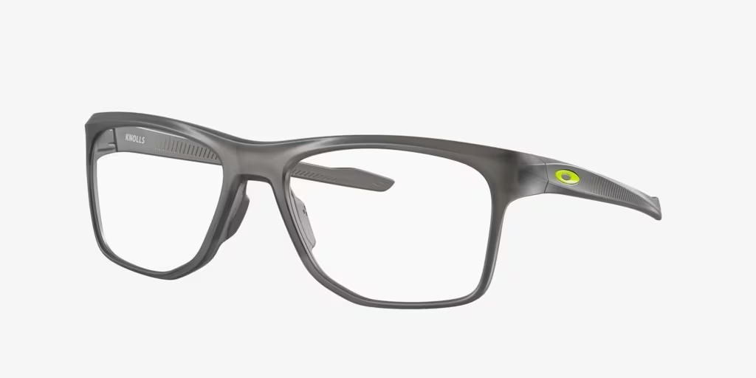
Brand | MICHEAL KORS
Model Name | OX8144 KNOLLS
Price | RS 1699
PRODUCT DETAILS

